Ventnor City Cultural Arts Center
Young Peoples Summer Art Program
ART CAMP at the Beach!
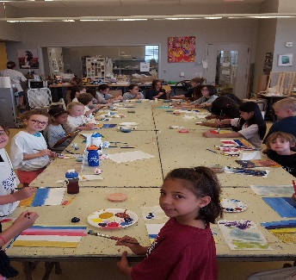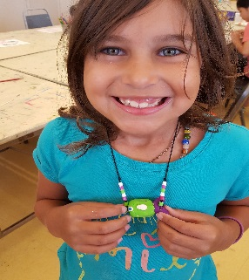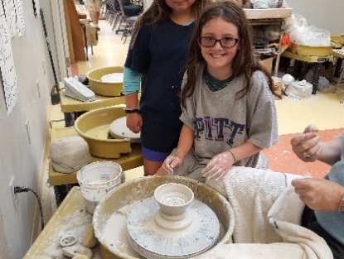
For kids ages 6- 12 only- Call (609)-823-7952 One week sessions, Mon.- Fri. 9am until 12 Noon
1. July 5th -9th - Fun with Clay- Jana Keeley
2.July 12th -16th – Fun with Clay with Jana Keeley OR…
- Dance & Tumbling – Ms. Gina Palmer
3. July 19th – 23rd ⁻ Crafts of all Kinds !! with Nancy La Re OR….
- Dance & Tumbling – Ms. Gina Palmer
4.July 26th- 30th - Mosaics and More – with Nancy La Re
5.August 2nd-6th- ART 101- painting and drawing- with Nancy
6.August 9nd 13th – Painting Down the Shore & more - with Arica
$175 per week Pre Registration is REQUIRED - NO WALK- INS !
2021 Summer Art Camp Registration
Childs Name - _______________________
Parents Name - _______________________
Address - ____________________________
Phone - _______________/back up_______________
Email _______________________________
Check which camp / week
1.. July 5th -9th - Fun With Clay or ________
- Dance &Tumbling ________
2.July 12th -16th - Fun With Clay or ________
-Dance &Tumbling ________
3.July 19th- 23rd - Crafts of All Kinds ________
4.July 26th - 30th - mosaics &more ________
5. August 2nd -6th Art 101 _______
6. August 9th-13th Painting Down the Shore _______

Total payment _________ PD _______

